**Source code :**

**Compile the code:**

prerequisite is JDK 1.6 or higher version



**Run the code:**

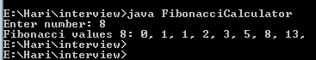

**Running the test cases using Junit:**

compiling the Junit test cases code adding the required jar files to classpath and running the test cases

